Nuclear Many-body Dynamics of the Radical Pair Mechanism
Main Results:
External Magnetic Field Magnitude Sensitivity:
- Greatest shift in singlet yield contrast happens around Zeeman strengths comparable to the strongest hyperfine coupling strengths in the nuclear environment at approximately 5-20mT.
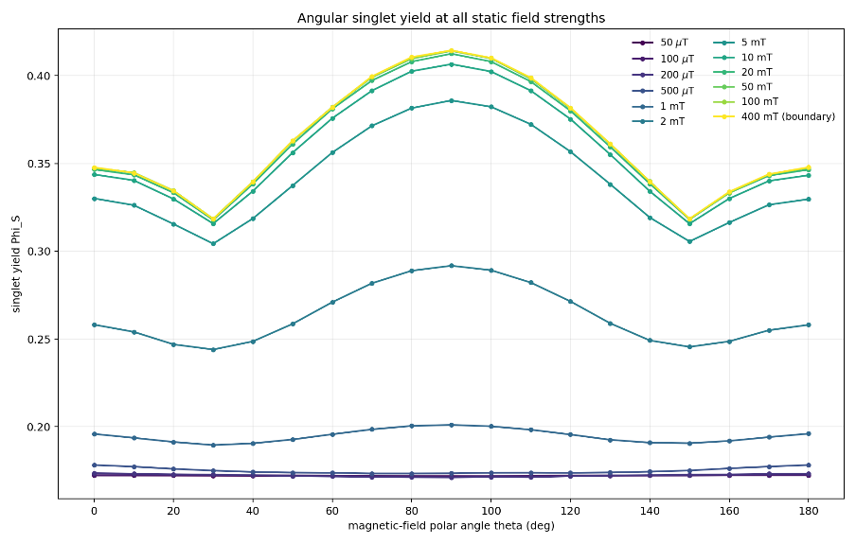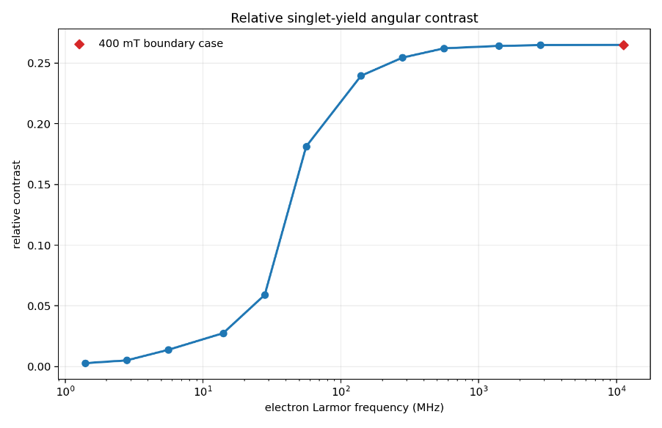

Entanglement Dynamics:
- RPM exhibits non-local system. Singlet entanglement between electrons flows into nuclear environment creating non-local correlations between the two molecules.
- Under closed-system, coherent dynamics the rpm exhibits high levels of entanglement.
- Careful consideration of such entanglement is necessary to for accurate numerical methods like tensor networks and matrix product states.
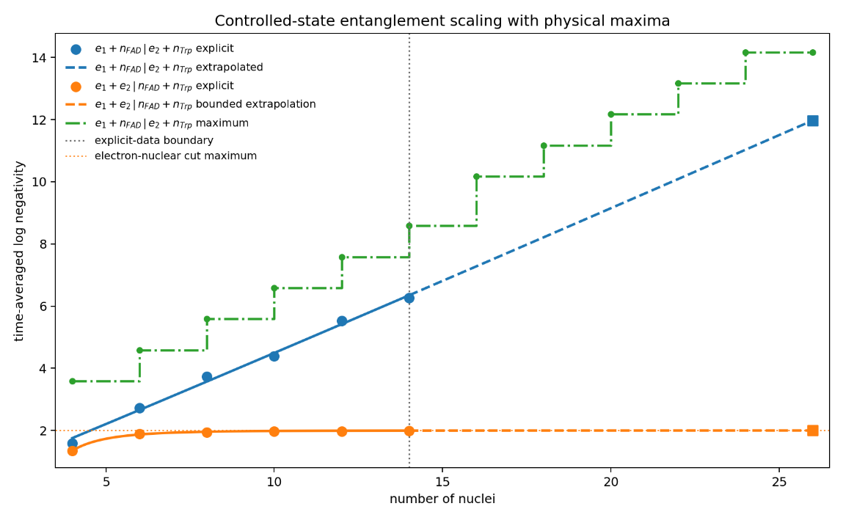

Overhauser Field Comparison:
- Semiclassical approximations like the Overhauser field are unlikely to capture accurate spin dynamics at weak field strengths as compared to the hyperfine environment. Fields at ~50uT
- As Zeeman field strength grows as compared to the hyperfine coupling strengths, the Overhauser representation tends to capture more accurately the singlet yield dynamics of the system.
- Once the Zeeman strength is about an order of magnitude greater than the hyperfine couplings (~ 20mT or ~500MHz for electron resonant frequencies) does the Overhauser start to accurately capture the singlet yield dynamics of the system.
- This is because the anisotropic effect of nuclei becomes less relevant as secular approximations become more accurate.
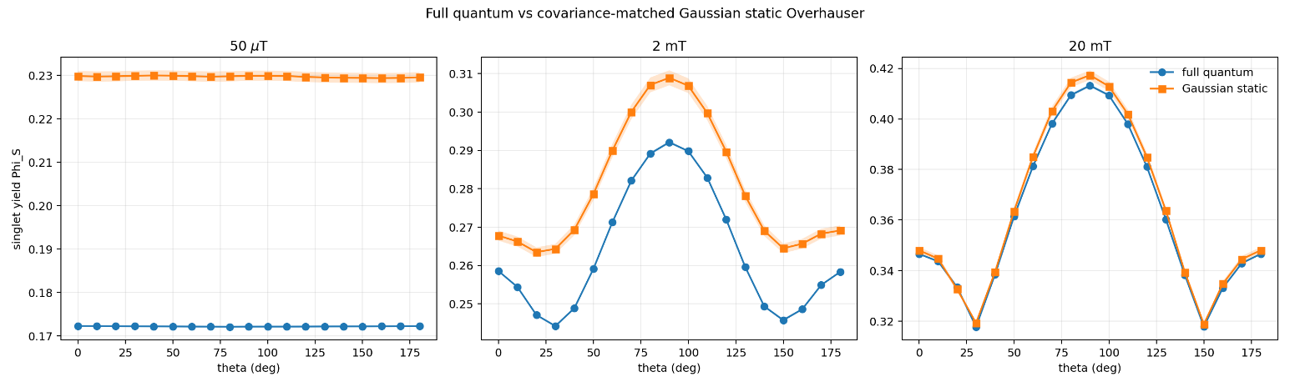
Nuclear Spin Flip Control
- Periodic spin flips (pi-pulses) of the strongest, hyperfine-coupled nucleus on the FAD molecule (N10) can dampen the angular sensitivity of the singlet yield.
- This is due to the reversing of the anisotropy of the weaker coupling axis within the hyperfine coupling tensor on N10.

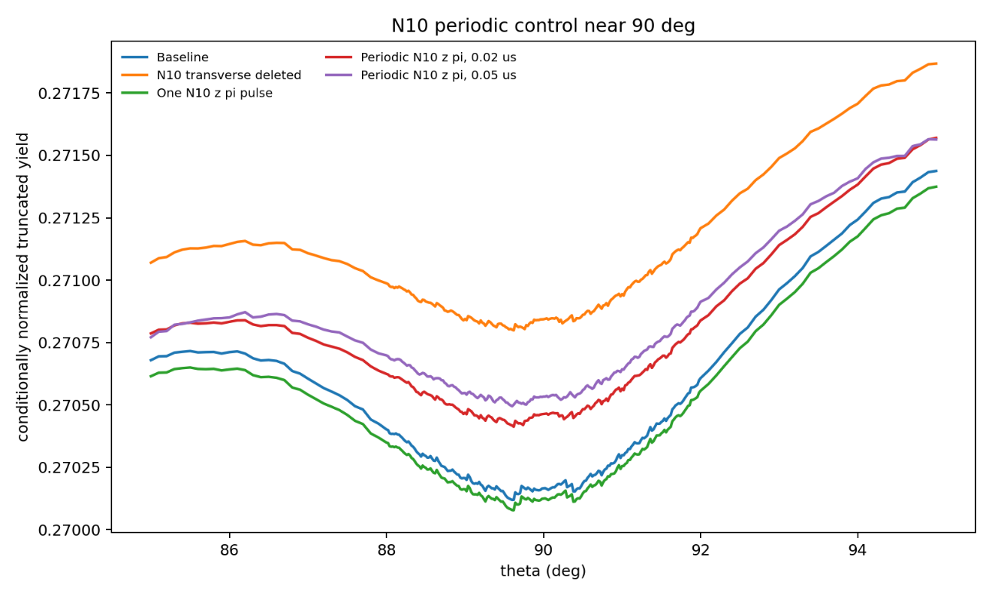

Nuclear Decay:
- thesis results showed: depending on the level of entanglement between the expelled nuclear decay products (electron and antineutrino) and the remaining proton, the decay process can significantly affect the singlet dynamics of the RPM
*I still need to produce the results for a larger system beyond the toy model used for the thesis.

